Dynamic Analysis Lab
Grand Canyon University - College of Engineering and Technology
CYB-320 Malware Analysis
Dr. Michael Varnadore
Liela Pressley
09/15/2024
Lab Questions:
1.What information was found for each file sample? Support your answer with evidence.
File size, type, hash number, last AV scan results, last sandbox report, antivirus results (crowdstrike falcon and metadefender), Falcon Sandbox reports for each OS (with threat score, indicators, and main characteristics), relations (executions parents, file collections, file dropped by), incident response risk assessment (remote access, spyware, persistence, fingerprint, network behavior: hosts contacted), the various MITRE Attack Techniques Detected including: Execution, Persistence, Privilege Escalation, Defense Evasion, Discovery, Impact, Credential Access, Command/Control, Lateral Movement, Collection, Exfiltration.
2.Was any network activity identified for any of these samples? Support your answer with
Evidence.
Yes, you can see the network behavior of the malware. For example, Lab-03-01 did not have network activity/contacted hosts:
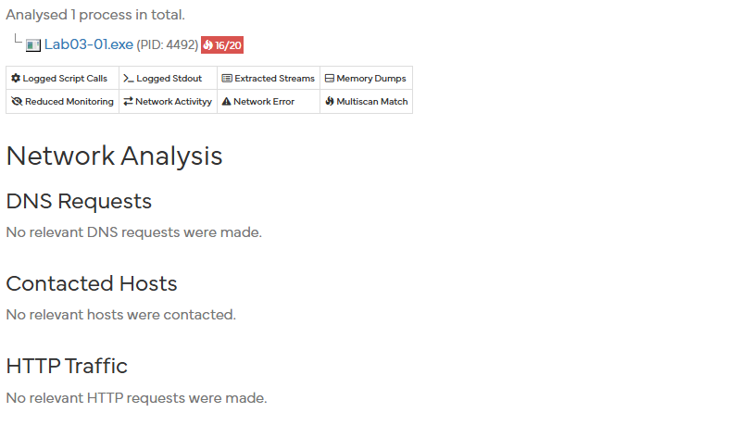
Lab-03-02 had 2 hosts contacted: 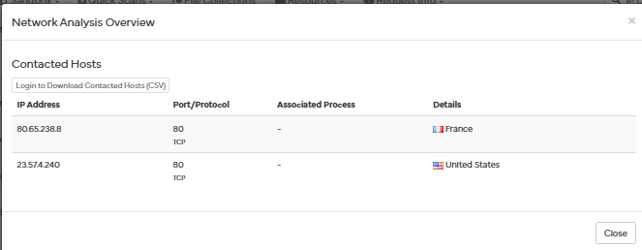
Lab03-03 had 1 host that was contacted: 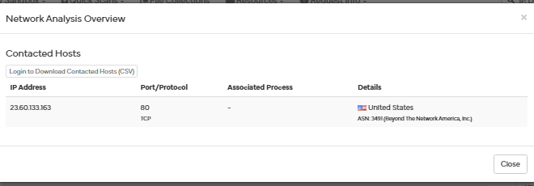
Lab03-04 had 2 hosts that were contacted.
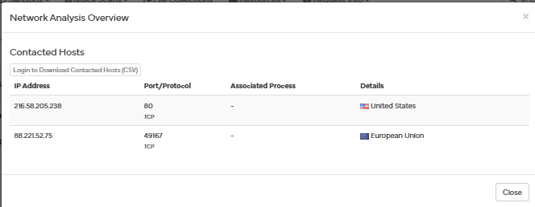
3.What reputable sandbox environments can be used to execute malware in a controlled
environment? Support your answer with evidence.
There is a wide variety of sandbox environments that can be used when analyzing malware. The two most common amongst professionals are Norman Sandbox and GFI Sandbox. Some other popular sandbox environments include Anubis, Joe Sandbox, ThreatExpert, BitBlaze, Comodo Instant Malware Analysis and more. These sandboxes are great as they provide output that is easy to understand and are useful for initial triage(Sikorski & Honig, 2012).

4.What are several other useful resources for dynamic analysis?
Support your answer with
Evidence.
One of the most essential tools when performing dynamic analysis of malware is having a reliable virtual machine environment that you can have the sandbox work within. This reduces the risk of your main Host Device being infected by the malware that is going to be run for testing. Some useful and customizable VM environments include VirtualBox, VMware, Linux distro. Another resource includes malware analysis environments which have tools pre built within the VM which include Flame VM, Remnux, Cuckoo Sandbox and Zero Wine (Stamm, 2021).

5.What are the advantages and weaknesses of dynamic analysis tools and techniques? Provide
a minimum of three each. Support your answer with evidence.
Strengths:
Using tools such as Process Explorer allow for the security professional/analyst to be able to better dissect the malware down to the tree structure of the different files parent to child processes in an updated (by second) view. Which provides a detailed view of the malware for thorough investigation in the files that otherwise would not be revealed in the static analysis. In this tool in particular, process’ status such as new, in process, terminated, services, etc. are indicated as well.
Using tools such Regshot within the dynamic analysis process allow the analyst to take/compare snapshots of the registry before and after the malware is run. This allows the analyst to see and determine the amount of noise/modifications were changed which can help in narrowing down the scope of where to investigate impacts of the malware.
Monitoring can be performed using tools such as Netcat or ApateDNS which provides insight on the network activity that occurs during the dynamic analysis process that otherwise can’t be determined without the malware running. You can catch the additional domains the malware could be using, act as a listener or even as the client to determine what ports the malware could be using or the different packets it is requesting.

Weaknesses:
When using a sandbox to execute the malware for dynamic analysis there will be functionalities that will not “trigger” if there is a certain command to control sequence that needs to be performed. Which will cause the sandbox to potentially miss out on some of the events that the malware could be capable of executing. In addition, there are some events that just take longer than the security professional or the sandbox allocated (or can afford) for. This can cause some functions to be missed as well.
Another weakness of using dynamic analysis tools such as a sandbox or VM is that most malware can detect when it is being run on a virtual machine then will stop or behave differently which can create an obstructed result.
Lastly, a weakness of using a sandbox is that some malware is crafted for specific circumstances and specific OS and if the sandbox is not created for that specific OS it may crash or run incorrectly.
(Sikorski & Honig, 2012).

6.What are some of the best practices for dynamic analysis? Support your answer with
evidence.
Dynamic analysis is great to be proactive in better understanding malware and applications so that data of behavior patterns can be collected and used to update signatures. One practice is for android based applications where dynamic analysis is used for malware detection and collection of system call traces while the app is running (Bhatia & Kaushal., 2017).

Sikorski, M., & Honig, A. (2012). Practical malware analysis : A hands-on guide to dissecting malicious software. No Starch Press, Incorporated.

Stamm, E. (2021, April 26). Malware analysis: your options to understanding their behavior. CSNP. https://csnp.org/post/malware-analysis-your-options-to-understanding-their-behavior#:~:text=Dynamic%20malware%20analysis%20involves%20the%20stages%20for,controlled%20environment%2C%20thereby%2C%20identifying%20how%2C%20where%2C%20or

T. Bhatia and R. Kaushal, "Malware detection in android based on dynamic analysis," 2017 International Conference on Cyber Security And Protection Of Digital Services (Cyber Security), London, UK, 2017, pp. 1-6, doi: 10.1109/CyberSecPODS.2017.8074847. keywords: {Smart phones;Malware;Tools;Classification algorithms;Algorithm design and analysis;Security;Feature extraction;Android;Malware Detection;Dynamic Analysis;System call;Benign;Malicious;Classification},

Screenshots
Lab03-01
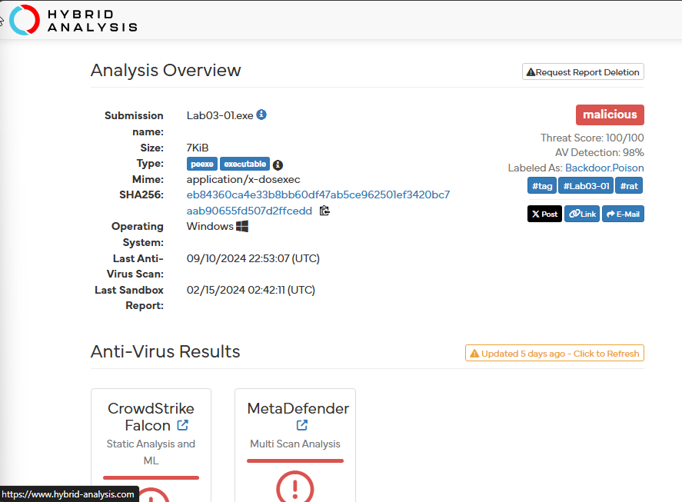
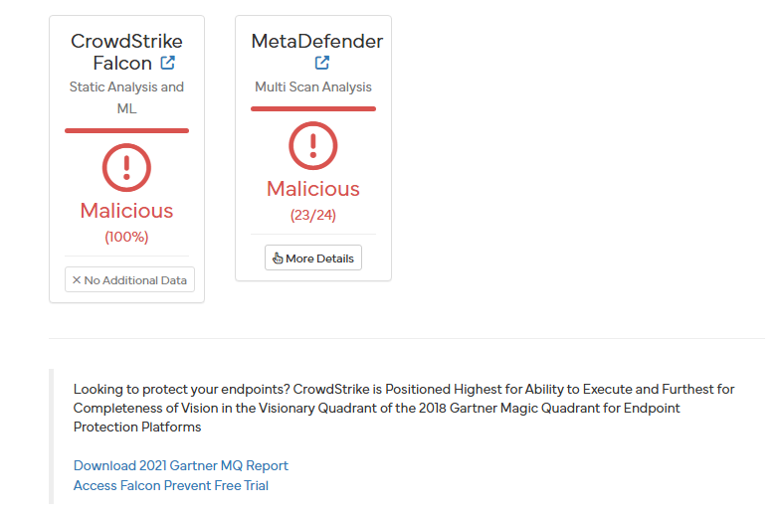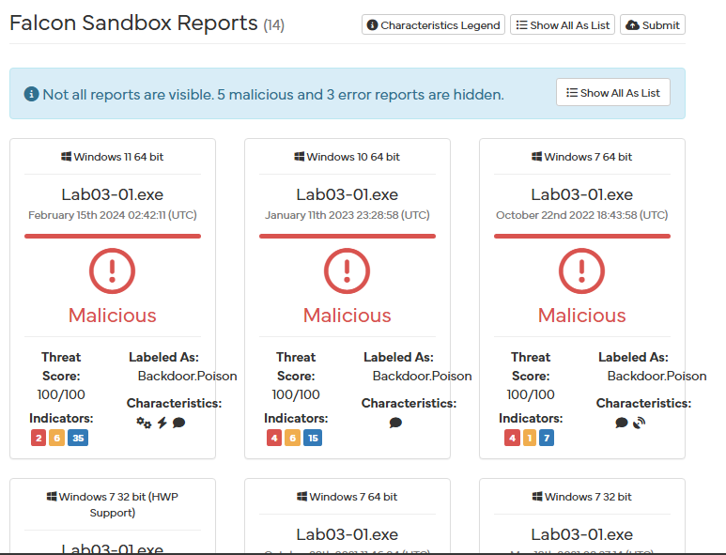
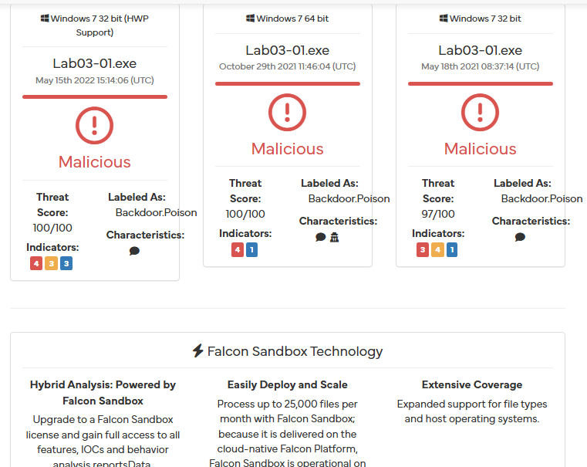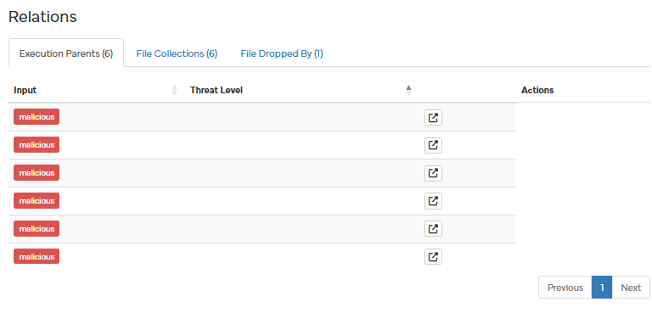
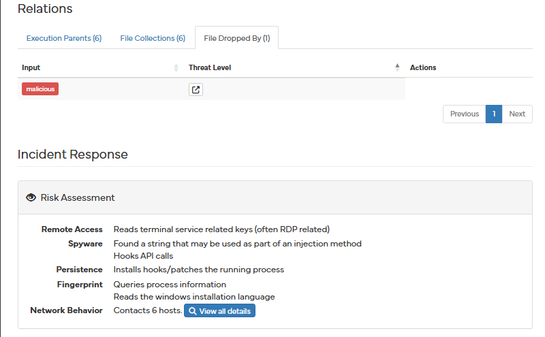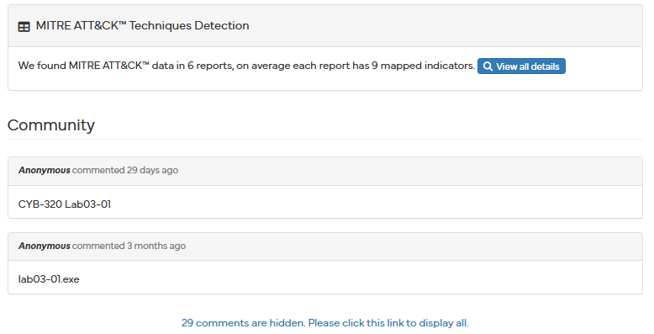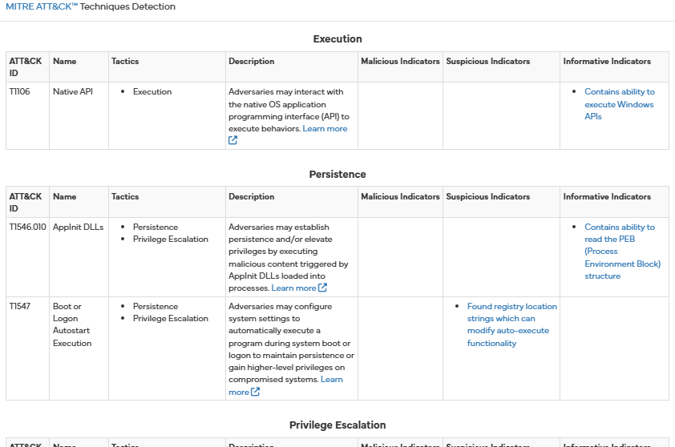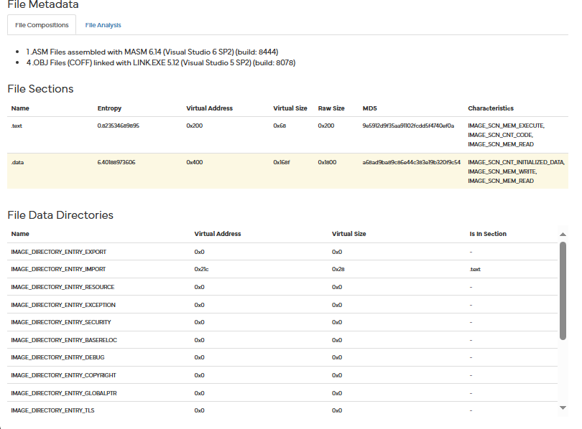

Lab 03-02
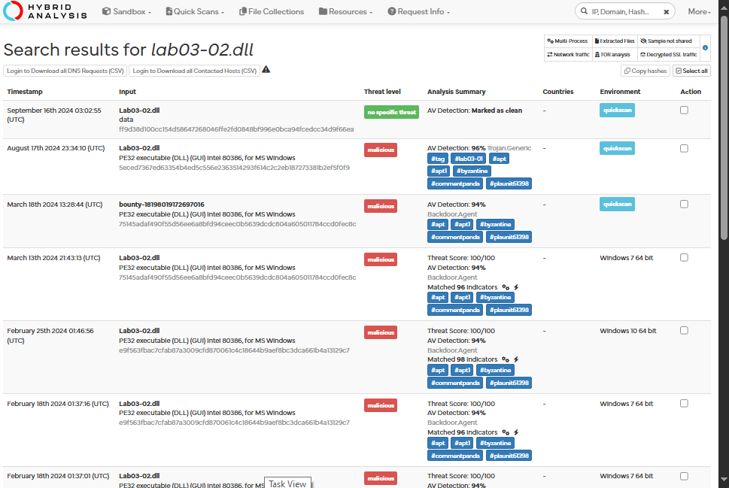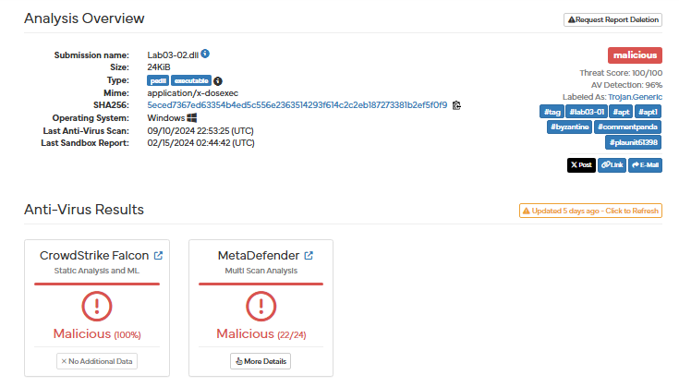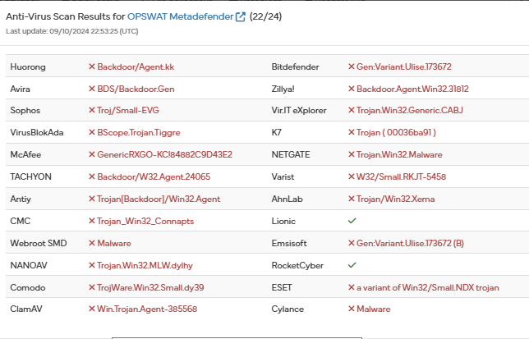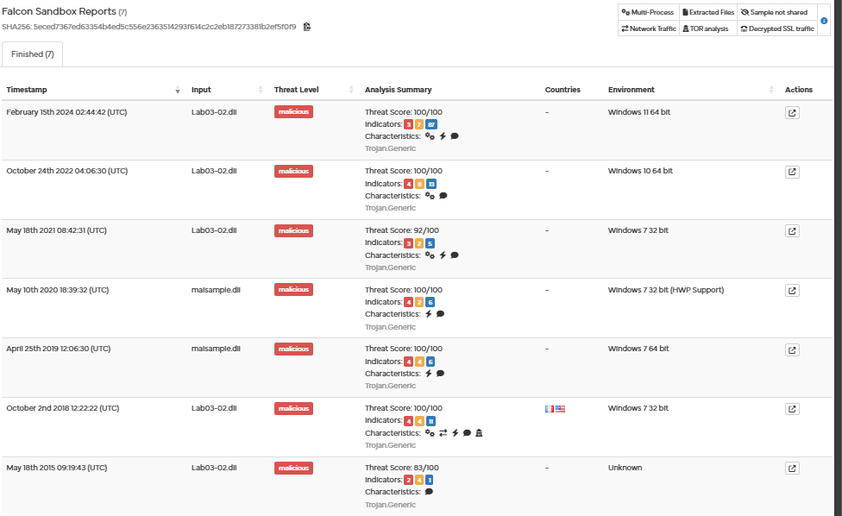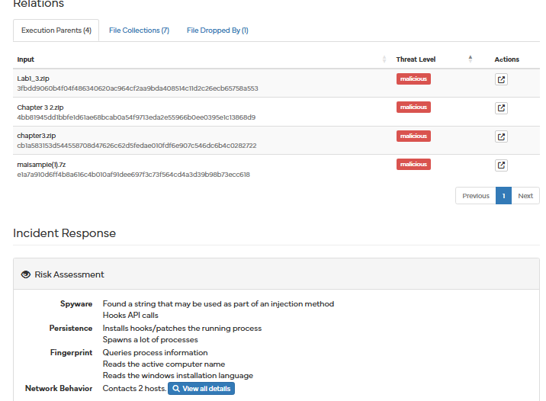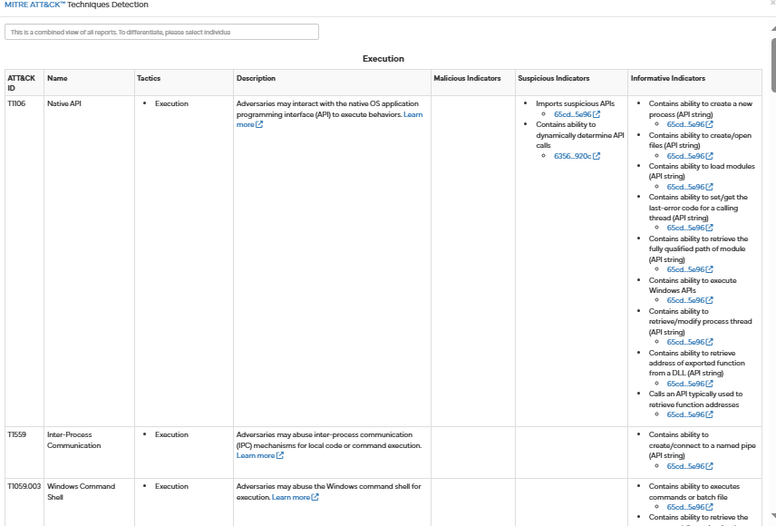

Lab03-03
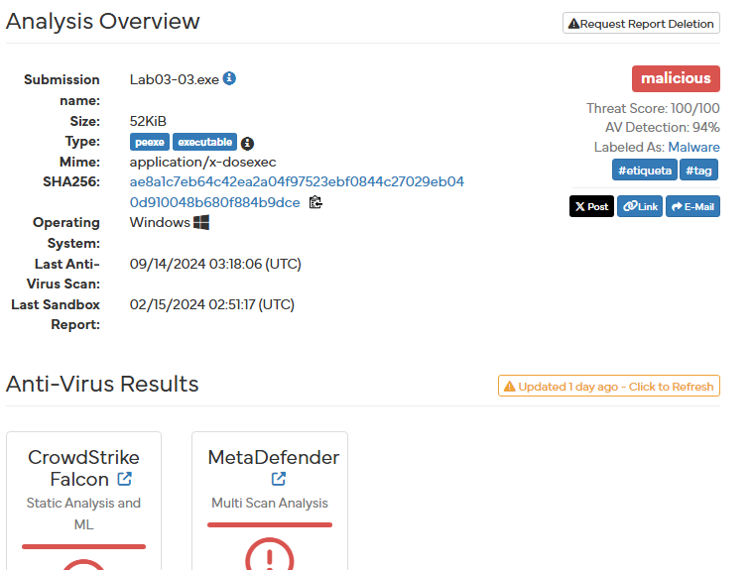
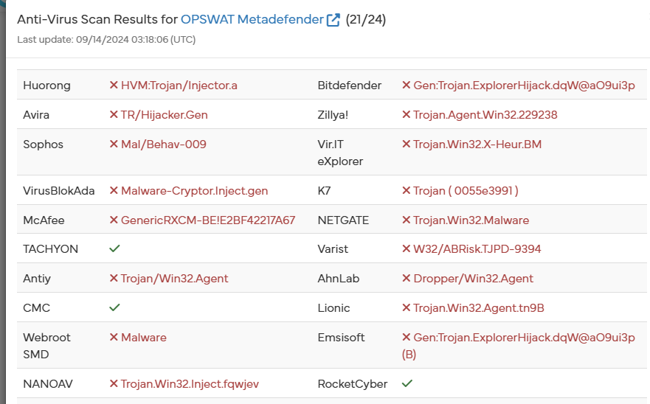
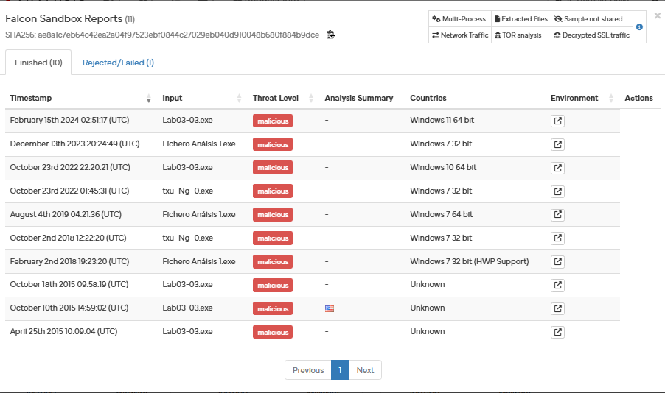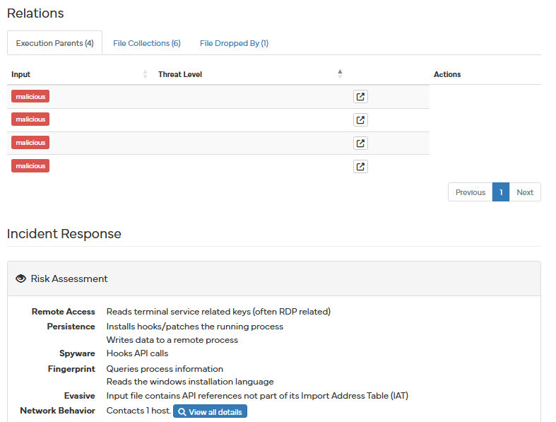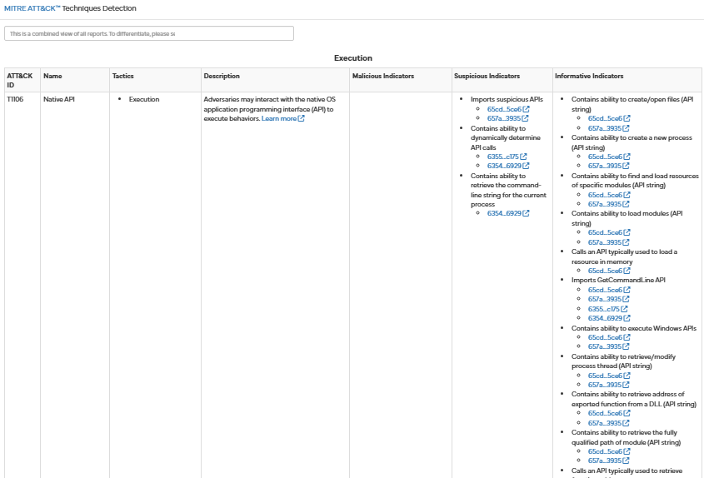
Execution, Persistence, Privilege Escalation, Defense Evasion, Discovery, Impact, Credential Access, Command/Control, Lateral Movement, Collection, Exfiltration

Lab3-04
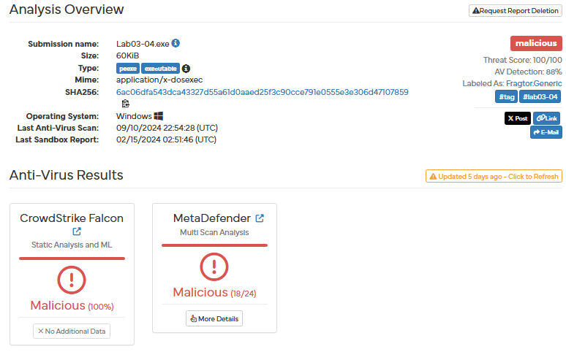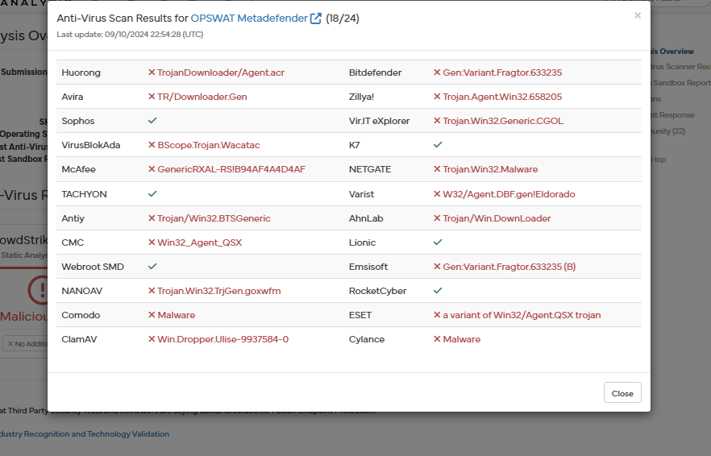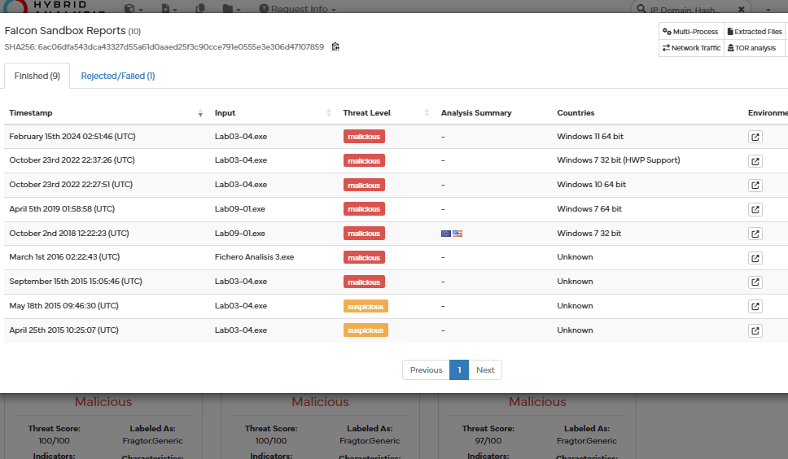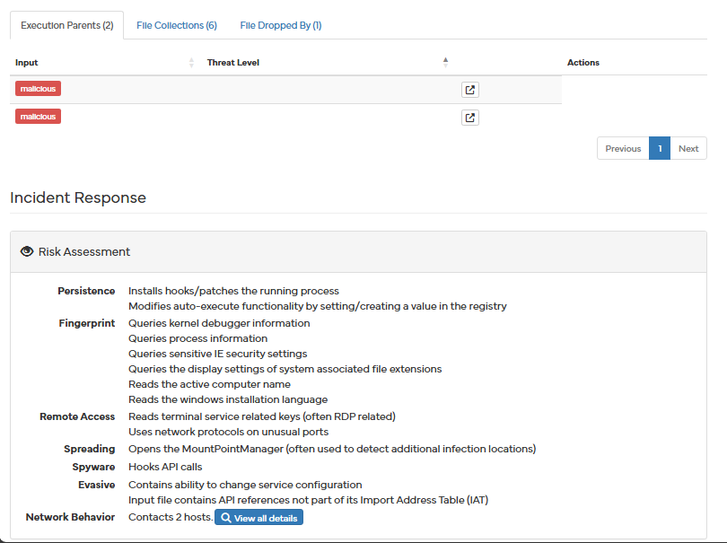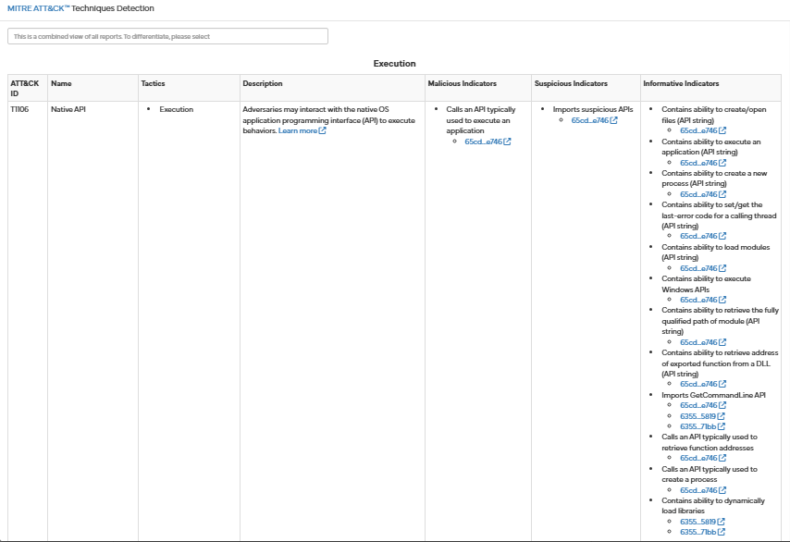
Execution, Persistence, Privilege Escalation, Defense Evasion, Discovery, Impact, Credential Access, Command/Control, Lateral Movement, Collection, Exfiltration

